**Chapter 17**

**Time Series Analysis and Forecasting**

**Case Problem 1: Forecasting Food and Beverage Sales**

1. Month 1 corresponds to January for year 1; month 2 corresponds to February for year 1; and so on. The time series plot is shown below:

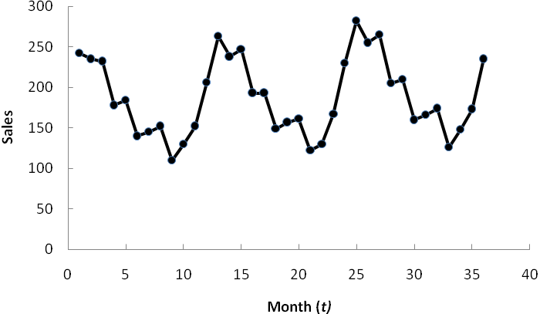

The time series plot indicates a linear trend and a seasonal pattern.

2. Analysis of seasonality:

|  |  |  |  |
| --- | --- | --- | --- |
| Month | Seasonal-Irregular Component Values | | Seasonal Index |
| January | 1.445 | 1.441 | 1.44 |
| February | 1.301 | 1.297 | 1.30 |
| March | 1.344 | 1.343 | 1.34 |
| April | 1.047 | 1.034 | 1.04 |
| May | 1.044 | 1.054 | 1.05 |
| June | .779 | .801 | .80 |
| July | .882 | .834 | .83 |
| August | .857 | .848 | .85 |
| September | .618 | .638 | .63 |
| October | .725 | .675 | .70 |
| November | .843 | .862 | .85 |
| December | 1.137 | 1.180 | 1.16 |

The deseasonalized time series is shown below:

|  |  |  |  |
| --- | --- | --- | --- |
| *t* | Deseasonalized Sales | *t* | Deseasonalized Sales |
| 1 | 168.06 | 19 | 189.16 |
| 2 | 180.77 | 20 | 189.41 |
| 3 | 173.13 | 21 | 193.65 |
| 4 | 171.15 | 22 | 185.71 |
| 5 | 175.24 | 23 | 196.47 |
| 6 | 175.00 | 24 | 198.28 |
| 7 | 174.70 | 25 | 195.83 |
| 8 | 178.82 | 26 | 196.15 |
| 9 | 174.60 | 27 | 197.76 |
| 10 | 185.71 | 28 | 197.12 |
| 11 | 178.82 | 29 | 200.00 |
| 12 | 177.59 | 30 | 200.00 |
| 13 | 182.64 | 31 | 200.00 |
| 14 | 183.08 | 32 | 204.71 |
| 15 | 184.33 | 33 | 200.00 |
| 16 | 185.58 | 34 | 211.43 |
| 17 | 183.81 | 35 | 203.53 |
| 18 | 186.25 | 36 | 202.59 |

The trend line fitted to the deseasonalized time series is

*T t* = 169.499 + 1.02 *t*

3. Sales forecasts

Forecast for Year 4

Using *T t* = 169.499 + 1.02 *t*

|  |  |  |  |
| --- | --- | --- | --- |
| Month | Trend Forecast | Seasonal Index | Monthly Forecast |
| January | 207.239 | 1.44 | 298.424 |
| February | 208.259 | 1.30 | 270.737 |
| March | 209.279 | 1.34 | 280.434 |
| April | 210.299 | 1.04 | 218.711 |
| May | 211.319 | 1.05 | 221.885 |
| June | 212.339 | .80 | 169.871 |
| July | 213.359 | .83 | 177.088 |
| August | 214.379 | .85 | 182.222 |
| September | 215.399 | .63 | 135.701 |
| October | 216.419 | .70 | 151.493 |
| November | 217.439 | .85 | 184.823 |
| December | 218.459 | 1.16 | 253.194 |

4. Forecast error = $295,000 - $298,424 = -$3,424

The forecast we developed over predicted by $3,424; this represents a very small error.

5. The analysis can be easily updated each month, especially if a computer software package is used to perform the analysis.

**Case Problem 2: Forecasting Lost Sales**

1. The data used for the forecast is the Carlson sales data for the 48 months preceding the storm. Using the trend and seasonal method, the seasonal indexes and forecasts of sales assuming the hurricane had not occurred are as follows:

|  |  |  |  |
| --- | --- | --- | --- |
| Month | Seasonal Index | Month | Forecast ($ million) |
| January | 0.957 | September | 2.16 |
| February | 0.819 | October | 2.54 |
| March | 0.907 | November | 3.06 |
| April | 0.929 | December | 4.60 |
| May | 1.011 |  |  |
| June | 0.937 |  |  |
| July | 0.936 |  |  |
| August | 0.974 |  |  |
| September | 0.797 |  |  |
| October | 0.936 |  |  |
| November | 1.119 |  |  |
| December | 1.677 |  |  |

2. The data used for this forecast is the total sales for the 48 months preceding the storm for all department sores in the county. Using the trend and seasonal method, the seasonal indexes and forecasts of county-wide department store sales assuming the hurricane had not occurred are as follows:

|  |  |  |  |
| --- | --- | --- | --- |
| Month | Seasonal Index | Month | Forecast ($ million) |
| January | 0.773 | September | 50.55 |
| February | 0.813 | October | 53.20 |
| March | 0.976 | November | 66.78 |
| April | 0.935 | December | 103.11 |
| May | 0.989 |  |  |
| June | 0.924 |  |  |
| July | 0.901 |  |  |
| August | 1.017 |  |  |
| September | 0.861 |  |  |
| October | 0.907 |  |  |
| November | 1.141 |  |  |
| December | 1.763 |  |  |

3. By comparing the forecast of county-wide department store sales with actual sales, one can determine whether or not there are excess storm-related sales. We have computed a "lift factor" as the ratio of actual sales to forecast sales as a measure of the magnitude of excess sales.

|  |  |  |  |
| --- | --- | --- | --- |
|  | Forecast Sales ($ million) | Actual Sales ($ million) | Lift Factor |
|  | 50.55 | 69.0 | 1.365 |
|  | 53.20 | 75.0 | 1.410 |
|  | 66.78 | 85.2 | 1.276 |
|  | 103.11 | 121.8 | 1.181 |
|  | 273.64 | 351.0 | 1.283 |

From the analysis a strong case can be made for excess storm related sales. For each month, actual sales exceed the forecast of what sales would have been without the hurricane. For the 4-month total, actual sales exceeded the forecast by 28.3%.

The explanation for the increase is that people had to replace real and personal property damaged by the storm. In addition, the additional construction workers, the disaster relief teams, and so on, created additional commercial activity in the area.

4. One approach would be to use the forecast of what sales would have been without the hurricane and then multiply by the lift factor to account for the excess storm-related sales. Such an estimate of lost sales is developed below:

|  |  |  |
| --- | --- | --- |
| Forecast ($ million) | Lift Factor | Lost Sales ($ million) |
| 2.16 | 1.365 | 2.948 |
| 2.54 | 1.410 | 3.581 |
| 3.06 | 1.276 | 3.905 |
| 4.60 | 1.181 | 5.433 |
|  | Total | 15.867 |

Based on this analysis, Carlson Department Stores can make a case to the insurance company for a business interruption claim of $15,867,000.

Another approach would be to use the 48 months of historical data to compute a market share for Carlson. That is, compute Carlson’s sales as a fraction of county-wide department store sales. Then you could develop a forecast of Carlson’s market share for September through December. Finally, an estimate of lost sales for each of the four months can be obtained by multiplying the forecasts of market share by the actual department store sales.